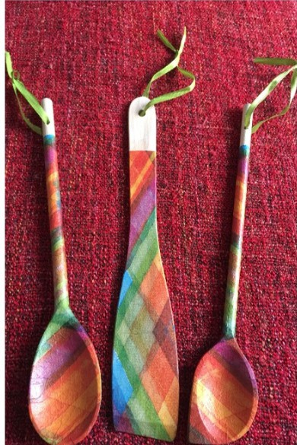**BUILDING AN ARTISANAL E-COMMERCE**

**PLATFORM WITH IBM CLOUD FOUNDRY**

PHASE 5

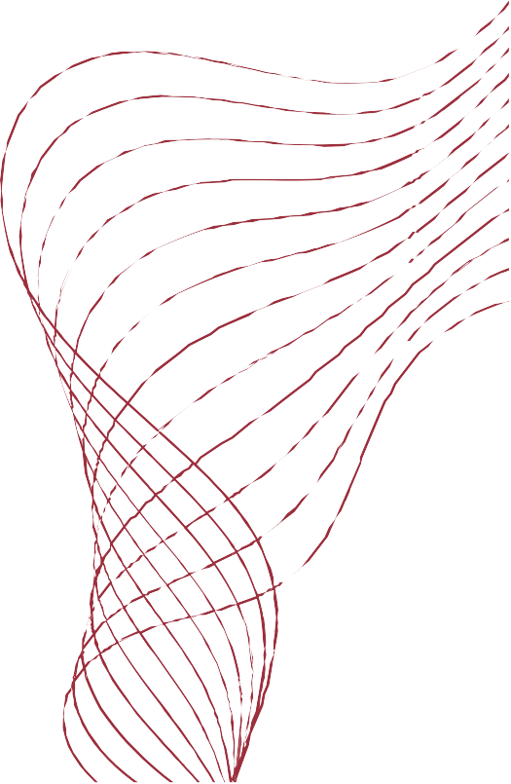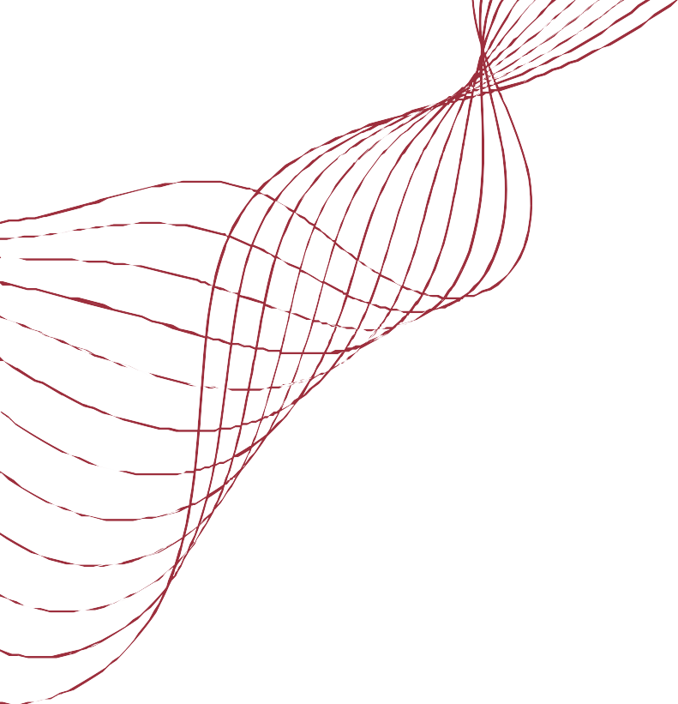

Final submission

**PROBLEM STATEMENT:**

 Building an artisanal e-commerce platform to connect skilled artisans with a global audience

 This application showcases their handmade products and provides features like secure shopping carts, payment gateways, and an intuitive checkout process

 Adding features which enhances Platform Design, Product Showcase, User Authentication, Shopping Cart and Checkout, Payment Integration, and User Experience



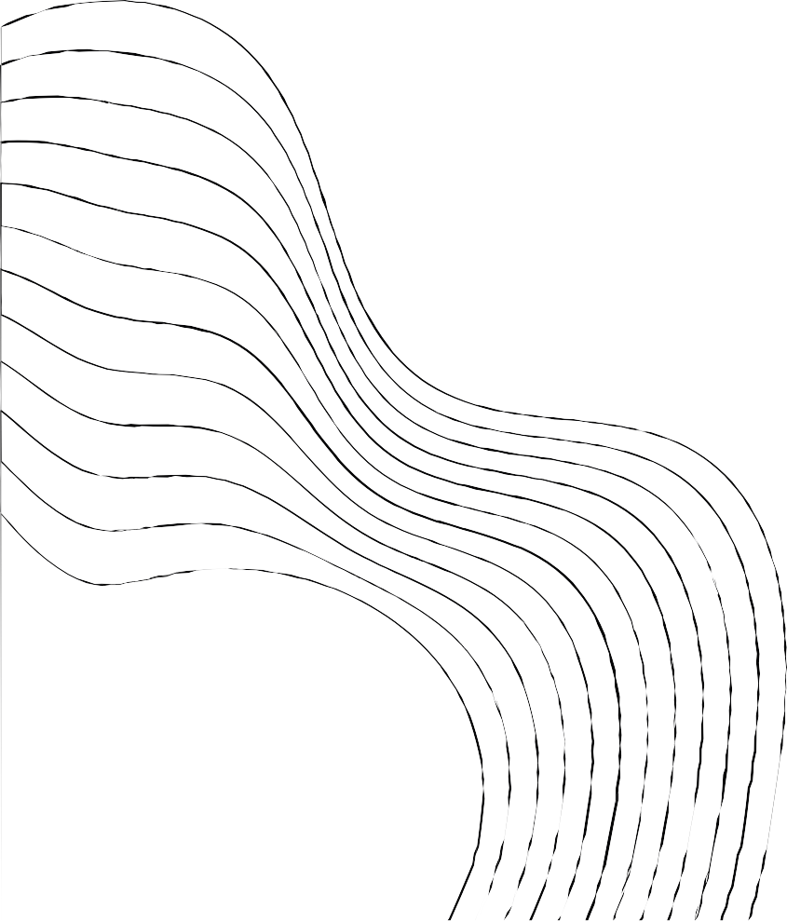

**01** Creating a login page or home page **02** Product showcase and discriptions **03** Authentication and registration

1. Modeling Shopping Cart and Checkout process
2. Secure Payment
3. Advanced user Experience
4. IBM cloud foundry
5. loading data into storage
6. products inserted into db2

**01**

CREATING A LOGIN PAGE OR HOME PAGE

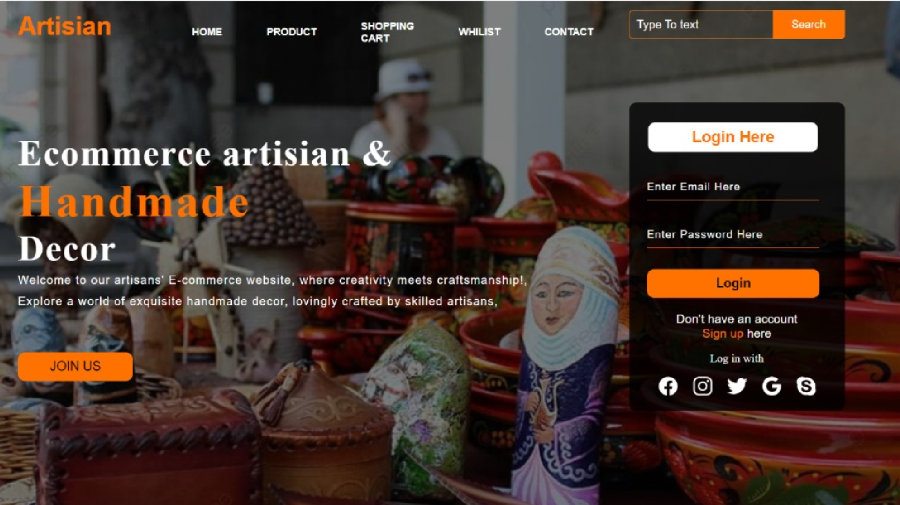

**IMPLEMENTED IN IBM CLOUD USING DB2**



**AND CLOUD**



**STORAGE**

